**A PROJECT REPORT**

**on**

**TITLE OF PROJECT REPORT**

***Submitted by***

**SACHIN KUMAR**

**AAKASH**

**ANIKET**

**ADITYA PARMAR**

***submitted in the partial fulfillment of the requirements for the award of degree***

***of***

**B.Tech**

**IN**

Electronics and Communication



Teacher Incharge: sh.Rohit Goel Project Guide : Sh.S.K.Jha

**The Technological Institute of Textile and Sciences, Bhiwani**

**MAHARISHI DAYANAND UNIVERSITY, ROHTAK**

(2020-24)

Department of Electronics and Communication

**Vision and Mission of INSTITUTE**

**VISION**

To become excellent knowledge enterprise*.*

**MISSION**

Creation of center of excellence for learning & research in engineering and technology.

**VISION AND MISSION OF DEPARTMENT**

***VISION***

Get access to future sustainable engineering*.*

**MISSION**

To apply the knowledge of mathematics, science, engineering fundamentals, and an engineering specialization to the solution of complex engineering problems.

**Table of contents**

**Contents****page no.**

Abstract 3

Motivation 4

Objective 5

List of components 6

Project summary 7-9

References 10

**OBJECTIVE**

As we always try to protect our car and also want that if there any possibility of touching it to any obstacle to prevent this unwanted damage of car this “**ULTRASONIC SECURITY SYSTEM”** is used. This system is also used in Robots also to prevent them from unwanted damage. As it will tell the user a little far from the obstacle. Today the customer believe on this system because they don’t want any damage and also in auto parking the car will automatically see its 3600 cameras and by combining the image this analyses the total obstacles and park the cars in very descent manner.

**MOTIVATION**

The motivation behind this project is to learn the technology that detect the intruders by the machine in their physical presence. As today it is becoming an important demand in every 4-wheeler. Where there are no security system including car then it can be installed in the wall which is rear to the vehicle. This important application of this device motivates us to make this project. This works in 1800 angle and up to 5-meter-long range. In x<5m it starts beeping and the LED’s starts lighting (where x is the distance between the wall and the car).

**ABSTRACT**

The proposed project “**Ultrasonic Security System**” is about anti-obstacle safety systems in robots and anti-collision in cars during parking to prevent them from touching to any wall or any car behind the car. Mainly use in auto parking technology consisting of cars. As it is the most demanded technology toward which every customer is attracted.

**LIST OF COMPONENTS**

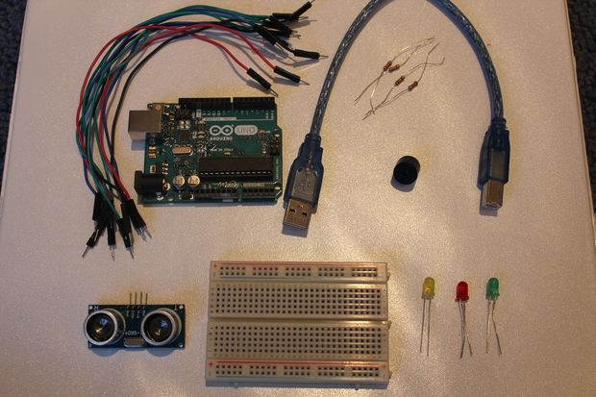

* Breadboard (generic)
* Ultrasonic Sensor HC-SR04 (Generic)
* Buzzer
* Resistor 221 ohm
* Jumper wires (generic)
* Arduino UNO
* LED (generic)

**ULTRASONIC SECYURITY SYSTEM**

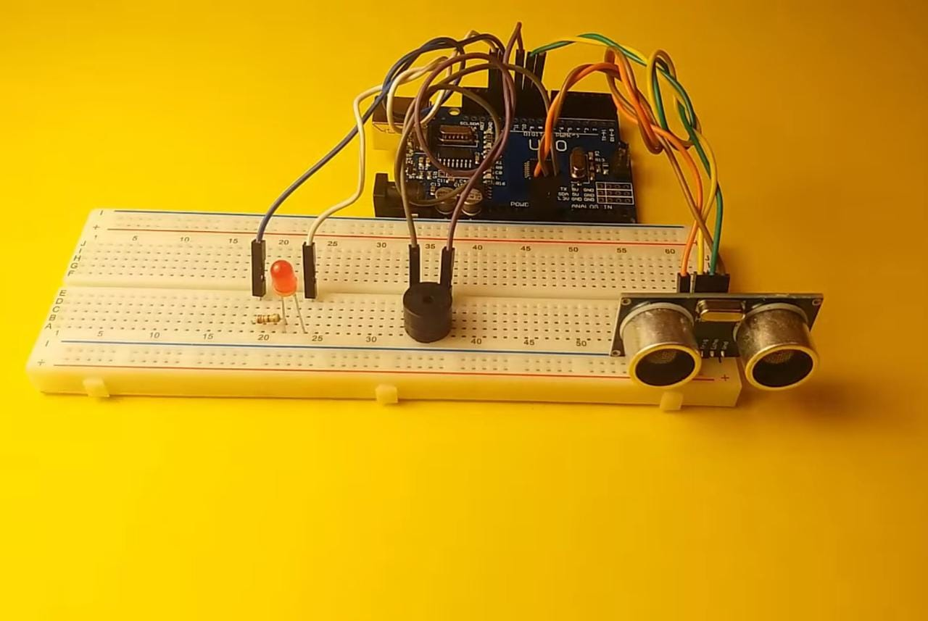

Project SUMMARY:

Connect a red wire from the 5V pin on the Arduino to the positive channel of the breadboard. Connect a black wire from the GND pin on the Arduino to the negative channel of the breadboard:

Buzzer = +ve->pin 11 and -ve-> GND

On Ultrasonic Sensor:

Echo = pin 10

Trig = pin 9

Vcc->+5v

GND->GND

LEDs:

+ve(Long Leg)= pin 13

-ve(Short Leg)= GND

The green wires connected to the LEDs should be connected in line to the positive side of the LED, while the negative side of the LED should be connected to the negative channel of the breadboard using a 220 ohm resistor.

Time to connect the HC-SRO4 ultrasonic sensor! A great tip is to place the ultrasonic sensor as far right to the breadboard as possible and make sure that it is facing out. Referring back to the setup picture, you should connect the GND pin on the ultrasonic sensor to the negative channel on the breadboard. Next connect the Trig pin on the sensor to pin 2 on the Arduino and connect the Echo pin on the sensor to pin 3 on the Arduino. Lastly, connect the VCC pin on the ultrasonic sensor to the positive channel on the breadboard.

The next step is to connect the LED's to the breadboard and Arduino. If you need to, I highly recommend that you refer back to the setup picture (Step 2), attaching the LEDs is pretty easy, there's a lot of repetition. Let's first attach the Green LED. So the way to do this, is to connect the anode (the longer leg) to pin 6 on the Arduino with a green wire, and to connect the cathode (the shorter leg) to the negative channel on the breadboard, using a 220 ohm resistor. Then repeat that step for the Yellow and then the Red LED, make sure to connect the anode (the longer leg) of the yellow LED to pin 5 on the Arduino and then connect the anode of the red LED to pin 6. Once you have done that, your setup should look similar to the picture above.

Resistors are not absolutely necessary, however they are highly recommended to be used.

The last part of the setup for this, is connecting the buzzer to the breadboard and the Arduino. This is one of the easiest parts of the whole setup. All that is required to do is to connect the longer leg of the buzzer to pin 7 of the Arduino using a green wire and then connect the shorter leg of the buzzer to the negative channel of the breadboard using a 220 ohm resistor.

It is HIGHLY recommended to use a resistor in connecting the shorter leg of the buzzer to the negative channel of the breadboard. This greatly reduces the volume of the buzzer and prevent it from dying to quickly.

Reference

* Chen, S., and Huang, C. (2017). Development of a low-cost Ultrasonic Security System. Journal of Physics: Conference Series, 892(1), 012020. Doi: 10.1088/1742-6596/892/1/012020
* Garg, N., and Kumar, A. (2018). Ultrasonic Sensor based home security system. International Journal of Computer Science and Mobile Computing, 7(5), 111-116.
* Ranganathan, S., and Seshadri, S. (2019). Design and implementation of an Ultrasonic-Based Security System for a smart home. International Journal of Innovative Technology and Exploring Engineering and Engineering, 8(10), 3485-3490.
* Singh, S., and Kumar, A. (2017). Development of a wireless Ultrasonic Security System for real-time monitoring. International Journal of Engineering and Technology, 9(2), 776-780.